**МІНІСТЕРСТВО ОСВІТИ І НАУКИ УКРАЇНИ**

**НАВЧАЛЬНО-НАУКОВИЙ КОМПЛЕКС**

**«ІНСТИТУТ ПРИКЛАДНОГО СИСТЕМНОГО АНАЛІЗУ»**

**НАЦІОНАЛЬНОГО ТЕХНІЧНОГО УНІВЕРСИТЕТУ УКРАЇНИ**

**«КИЇВСЬКИЙ ПОЛІТЕХНІЧНИЙ ІНСТИТУТ»**

**КАФЕДРА МАТЕМАТИЧНИХ МЕТОДІВ СИСТЕМНОГО АНАЛІЗУ**

**Практична робота №1**

**з курсу «Комп'ютерні мережі»**

**Виконала: студентка 3 курсу**

**групи КА-74**

**Крутько А.О.**

**Прийняв: Кухарєв С.О.**

**Київ – 2020р.**

**Запит:**

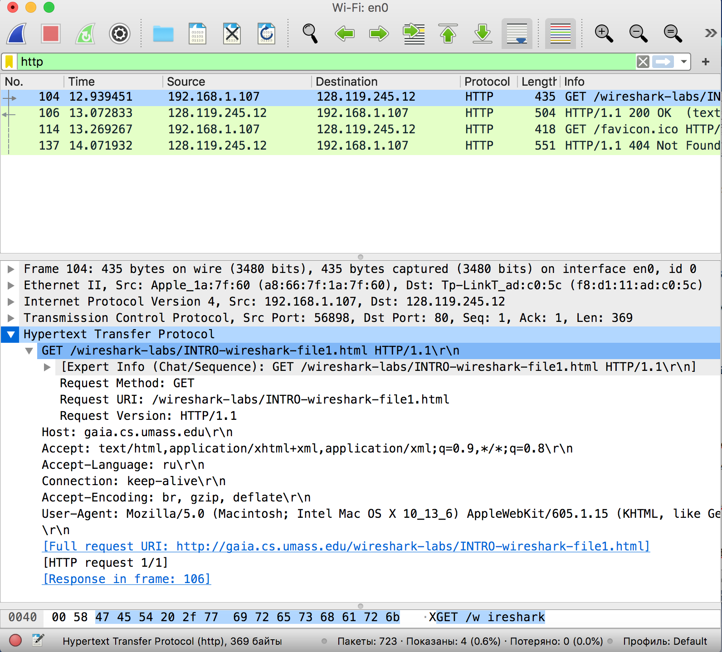

**Відповідь:**

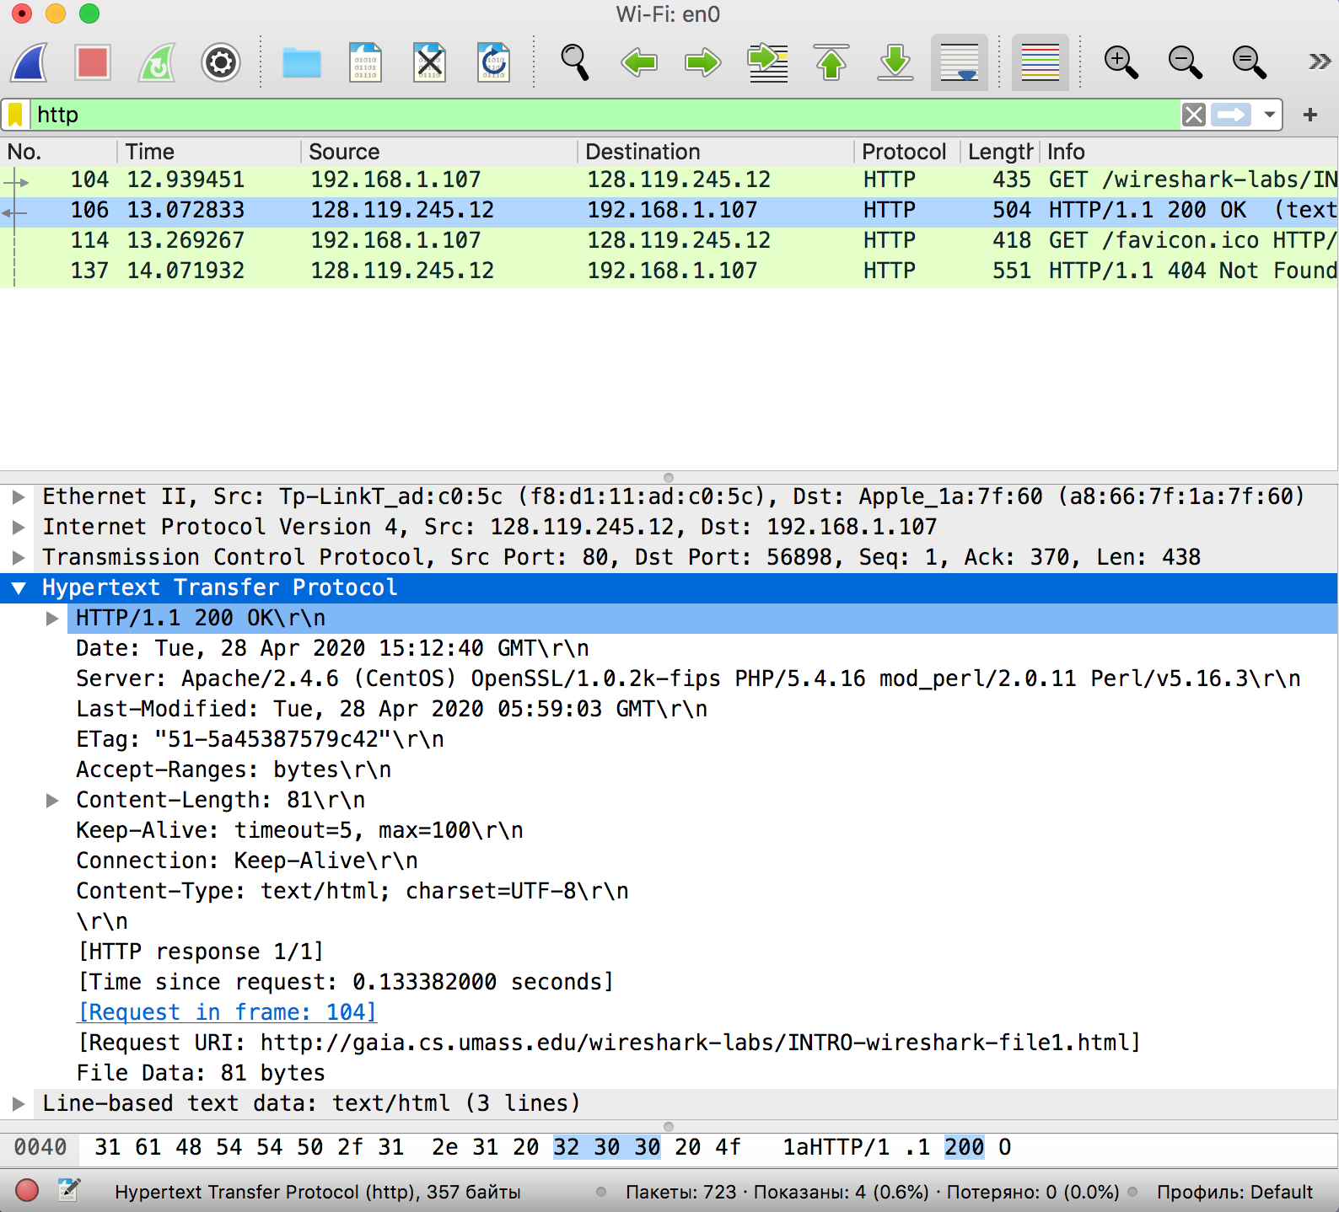

**Повторний запит:**

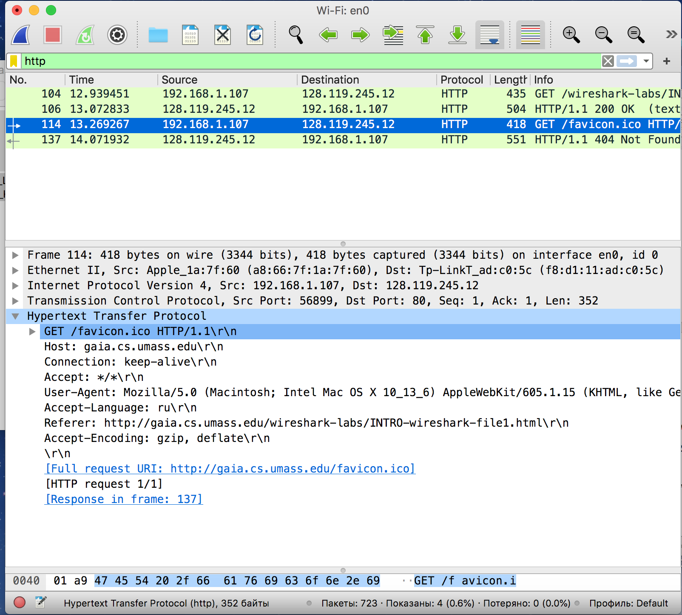

**Відповідь:**

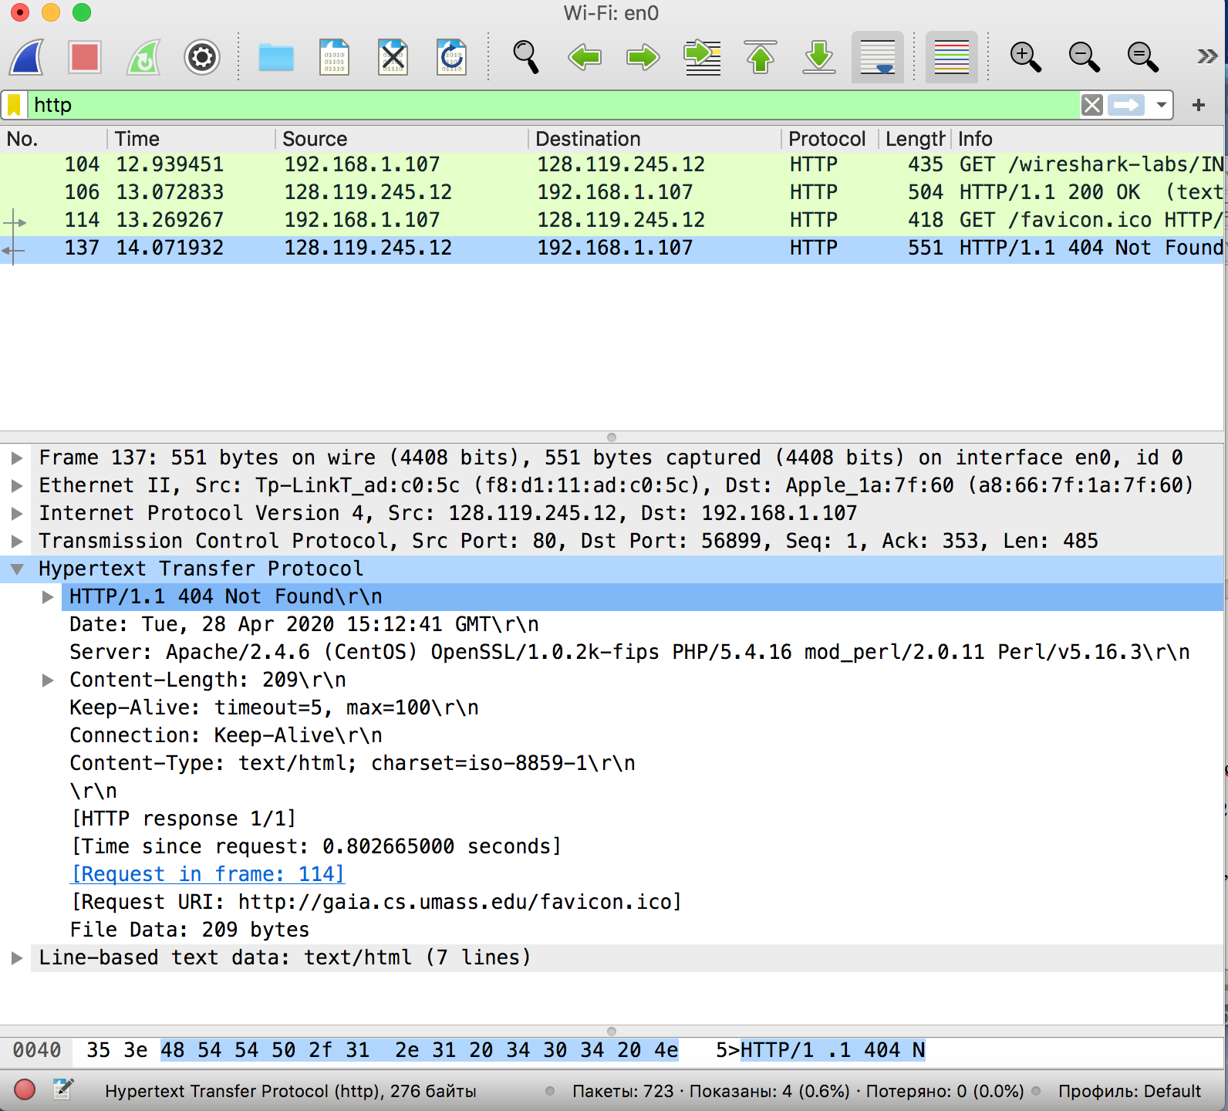

**Контрольні запитання:**

1. Які протоколи відображалися в вікні лістингу протоколів до включення фільтрації?

MDNS, SSDP, ICMPv6, DNS, ICMP, TCP, IGMPv2

In computer networking, the multicast Domain Name System (mDNS) resolves host names to IP addresses within small networks that do not include a local name server. It is a zero-configuration service, using essentially the same programming interfaces, packet formats and operating semantics as the unicast Domain Name System (DNS).

The Simple Service Discovery Protocol (SSDP) is a network protocol based on the Internet Protocol Suite for advertisement and discovery of network services and presence information. It accomplishes this without assistance of server-based configuration mechanisms, such as the Dynamic Host Configuration Protocol (DHCP) or the Domain Name System (DNS), and without special static configuration of a network host. SSDP is the basis of the discovery protocol of Universal Plug and Play (UPnP) and is intended for use in residential or small office environments.

Internet Control Message Protocol version 6 (ICMPv6) is the implementation of the Internet Control Message Protocol (ICMP) for Internet Protocol version 6 (IPv6) defined in RFC 4443.[1] ICMPv6 is an integral part of IPv6 and performs error reporting and diagnostic functions (e.g., ping), and has a framework for extensions to implement future changes.

The Domain Name System delegates the responsibility of assigning domain names and mapping those names to Internet resources by designating authoritative name servers for each domain.

The Internet Control Message Protocol (ICMP) is one of the main protocols of the internet protocol suite. It is used by network devices, like routers, to send error messages indicating, for example, that a requested service is not available or that a host or router could not be reached. ICMP can also be used to relay query messages. It is assigned protocol number 1. ICMP differs from transport protocols such as TCP and UDP in that it is not typically used to exchange data between systems, nor is it regularly employed by end-user network applications (with the exception of some diagnostic tools like ping and traceroute).

The Transmission Control Protocol provides a communication service at an intermediate level between an application program and the Internet Protocol. It provides host-to-host connectivity at the Transport Layer of the Internet model.

The Internet Group Management Protocol (IGMP) is a communications protocol used by hosts and adjacent routers on IPv4 networks to establish multicast group memberships. IGMP is an integral part of IP multicast. IGMP can be used for one-to-many networking applications such as online streaming video and gaming, and allows more efficient use of resources when supporting these types of applications. IGMP is used on IPv4 networks. Multicast management on IPv6 networks is handled by Multicast Listener Discovery (MLD) which uses ICMPv6 messaging in contrast to IGMP's bare IP encapsulation.

2. Які протоколи використовувалися в збережених пакетах запиту та відповіді?

Ethernet II, Internet Protocol Version 4, Transmission Control Protocol

3. Який період часу пройшов з часу відсилки першого пакету із запитом сторінки до отримання першого пакету з відповіддю сервера?

0.133382000 seconds

4. Якими були вихідна та цільова адреси пакетів із запитом та із відповіддю?

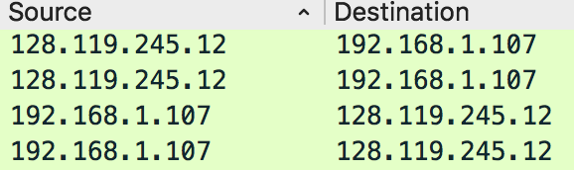

5. Яким був перший рядок запиту на рівні протоколу HTTP?

GET /wireshark-labs/INTRO-wireshark-file1.html HTTP/1.1\r\n

6. Яким був перший рядок відповіді на рівні протоколу HTTP?

HTTP/1.1 200 OK\r\n